**KWAME NKRUMAH UNIVERSITY OF SCIENCE AND TECHNOLOGY, KUMASI**



**DEPARTMENT OF MECHANICAL ENGINEERING**

**MECHANICAL ENGINEERING LAB 4 (ME 396)**

**LABORATORY EXPERIMENT: PUMP TEST**

**LECTURER: DR. Y.A.K. FIAGBE**

**TECHNICIAN: MR. DAVID MINGLE**

**LAB GROUP: GROUP A**

**DATE OF SUBMISSION: 16/04/2019**

**MEMBERS**

|  |  |
| --- | --- |
| **NAMES** | **INDEX NUMBERS** |
| 1.KORANTENG GARETH | 2289414 |
| 2.AFFUL JOSEPH KABENLA ANIMNYAM | 5967216 |
| 3.AMOATENG – MENSAH DAVID | 5968816 |
| 4.ATOMBOH, VINCENT ESSUMAN | 5971016 |
| 5.BOYE, SAMUEL | 5972816 |
| 6.ESHUN, EMMANUEL | 5974716 |
| 7.KRAMPAH EMMANUEL | 5976816 |
| 8.NYAMEKYE JOEL KWAKU | 5978816 |
| 9.OTCHERE SHADRACK APPIAH | 5980816 |
| 10.TETTEY ATTOH DERRICK | 5982816 |
| 11.ANSAH EMMANUEL ABBAN | 5969216 |
| 12.KOTEI SHANE NII AMON | 5976716 |

**EXPERIMENT**: **Pump Testing**

**OJECTIVE**

To investigate the performance characteristics of a Centrifugal pump.

**EQUIPMENTS**:

C3-MKII Multi Pump Test Rig (Centrifugal pump fitted permanently)

User Supplied PC with C3-MKII-306 software installed

Thermometer suitable for fluid temperature measurement

**DESCRIPTION OF THE CENTRIFUGAL PUMP**:

The centrifugal pump is the most commonly used pump for pumping water or similar liquids of low viscosity. The main characteristics of a centrifugal pump are:

* High flow rate at moderate temperature
* Flow that can be varied simply using a valve
* Not self-priming so the pump suction should be flooded at all times
* Flows that falls with increasing system pressure and reducing pump speed
* Simple design with no close tolerances necessary and no inlet or outlet valves required for sealing
* Performance can be adjusted by changing impeller diameter, impeller width, etc.

The centrifugal pump supplied consists of a single impeller incorporating radial blades that rotates inside a snail-shaped volute casing. Water enters axially at the eye of the impeller, spirals outwards and discharges at the periphery of the impeller into the volute casing. As the fluid passes through the pump, energy is imparted to it by the blades of the impeller resulting in fluid leaving the impeller with an increase of both pressure and velocity.

Centrifugal pumps are capable of transferring large volumes without any dependence on valves or fine clearances and can be run against a closed valve without developing a very high pressure. They can be designed to handle a wide range of slurries, or solids in suspension, in addition to liquids with moderate viscosities.

**DIAGRAM OF THE CENTRIFUGAL PUMP**

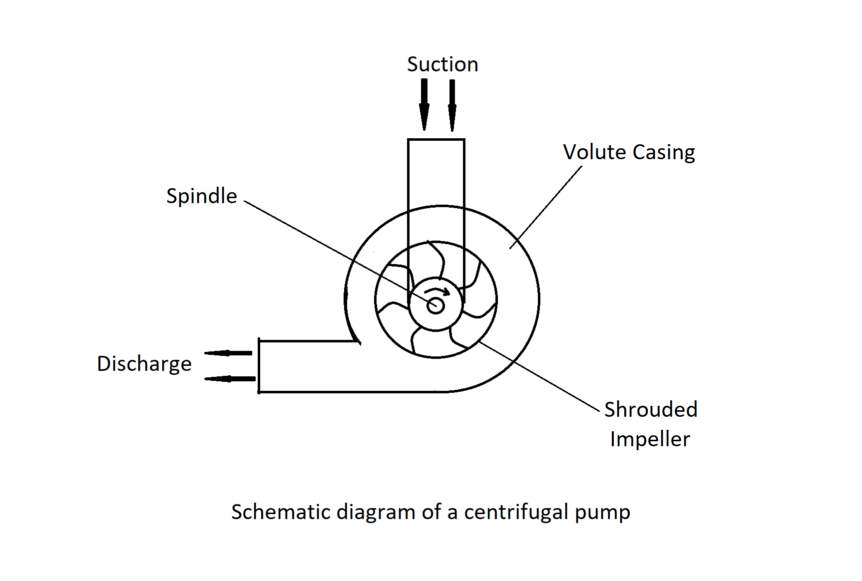

**EXPERIMENT SETUP:**

The centrifugal pump is permanently fitted to the C3-MKII and no changes are required for this exercise. It is advisable to retain the end-caps on the unused piping unless additional pumps have been connected to the low-pressure system.

Check that the reservoir on the C3-MKII has been filled with clean water and that the equipment is connected to an appropriate mains electricity supply.

If a thermometer is available remove the reservoir lid and measure the temperature of the water. Remove the thermometer and replace the reservoir lid.

Check that the USB cable is connected from the electrical console to the PC. Load the C3-MKII software then choose the centrifugal pump from the main menu. Check that **IFD:vCOM(x)m** is indicated in the bottom right hand corner of the screen where x is the number of the USB port.

Set the valves as shown in the diagram:8

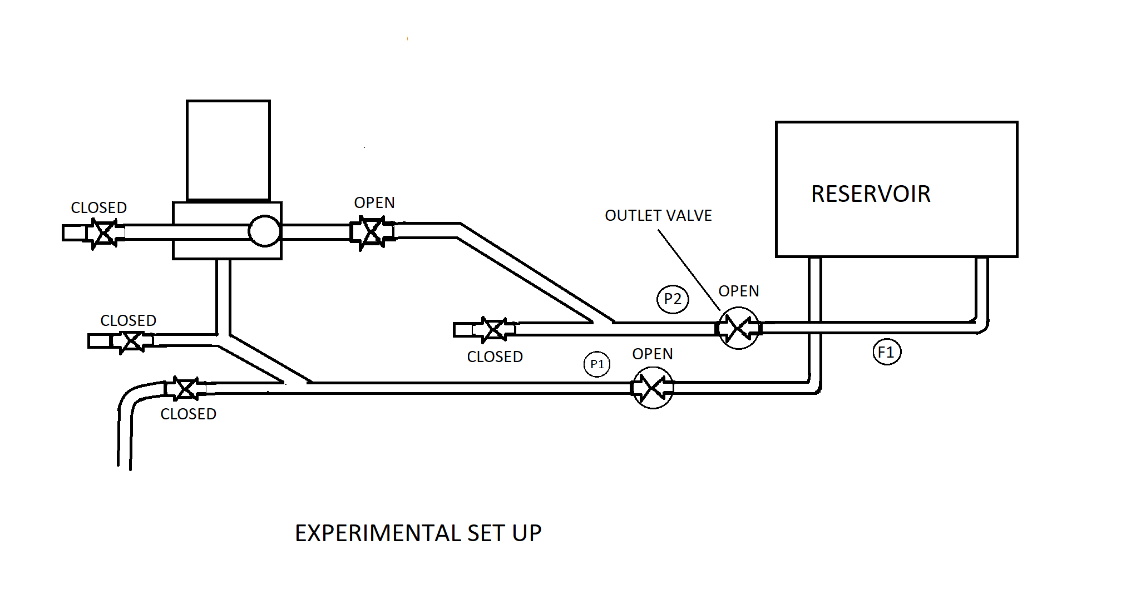

**PROCEDURE:**

We used the outlet valve only to adjust the discharge from the centrifugal pump. The other valves remained open or closed throughout the exercise, as marked on the diagram above. We started with the outlet valve fully open.

We connected the mains supply to the equipment then switch on the power switch on the electrical console.

If ‘Low Level’ is displayed on the mimic diagram fill the reservoir to approximately 75 mm from the top then confirm that the warning has disappeared.

If the temperature of the working fluid in the reservoir is known, enter the value in the box provided on the mimic diagram. The value will default to 20.0˚C if the actual value is not entered.

We run the pump at maximum speed for the first part of this exercise. We gradually increased the speed of the pump from 0% to 100% by clicking the ‘Pump Speed’ up button until the pump is running at maximum speed of 100%.

With the pump at 100% speed, we allowed the pump and pipe work to fully prime.

When the flow reading was steady, we clicked the (GO) icon and recorded all the of the instantaneous measured and calculated variables into the results table.

We gradually closed the outlet valve until the flow reading falls slightly, we then allowed the conditions to settle and recorded another set of readings by clicking the (GO) icon.

We continued to close the outlet valve in steps and record a set of values at each step until a flow rate of 0 l/min was reached. We recorded one more set of readings for zero flow conditions.

We then recorded additional sets of results for different pump speed settings, for example at 90%, 80% etc until the flow and pressure readings were minimal.

When sufficient readings have been taken, we then reduced the pump speed to 0% to stop the pump.

**RESULTS:**

The following readings were taken after the experiment

|  |  |  |  |  |  |  |  |  |
| --- | --- | --- | --- | --- | --- | --- | --- | --- |
| Pump  Speed  (rpm) | Flow  Rate  (l/min) | Inlet  Pressure  (N/m²) | Outlet  Pressure  (N/m²) | Torque  (Nm) | Speed  (rpm) | Power  (Watt) | Efficiency  (%) | Total  Head  (m) |
| 100 | 206 | -5.86 | 5.35 | 1.064 | 2847 | 317.10 | 12.20 | 1.14 |
| 80 | 161.7 | -4.34 | 3.64 | 0.710 | 2278 | 169.30 | 12.70 | 0.81 |
| 60 | 120.5 | -2.37 | 2.02 | 0.369 | 1706 | 66.00 | 13.40 | 0.45 |
| 40 | 82.5 | -1.01 | 0.91 | 0.141 | 1140 | 16.80 | 15.70 | 0.20 |
| 20 | 37.8 | -0.15 | 0.10 | 0.105 | 571 | 6.30 | 2.50 | 0.03 |

Table 1: Varying Pump Speed with corresponding data values

|  |  |  |  |  |  |  |  |  |
| --- | --- | --- | --- | --- | --- | --- | --- | --- |
| **Pump**  **Speed**  **(rpm)** | **Flow**  **Rate**  **(l/min)** | **Inlet**  **Pressure**  **(N/m²)** | **Outlet**  **Pressure**  **(N/m²)** | **Torque**  **(Nm)** | **Speed**  **(rpm)** | **Power**  **(Watt)** | **Efficiency**  **(%)** | **Total**  **Head**  **(m)** |
| 100 | 206 | -5.86 | 5.35 | 1.064 | 2847 | 317.10 | 12.20 | 1.14 |
| 100 | 164.8 | -3.79 | 37.37 | 1.073 | 2846 | 319.70 | 35.40 | 4.20 |
| 100 | 123.6 | -2.27 | 60.29 | 1.016 | 2846 | 302.7 | 42.70 | 6.38 |
| 100 | 82.4 | -1.06 | 83.12 | 0.649 | 2846 | 193.5 | 59.90 | 8.58 |
| 100 | 41.2 | -0.35 | 94.13 | 0.754 | 2846 | 224.8 | 28.90 | 9.63 |

Table 2: Constant Pump speed with varying flow rate

**CONCLUSION:**

The flow rate decreases as the speed decreases with pressure. The torque decreases as the power decreases.